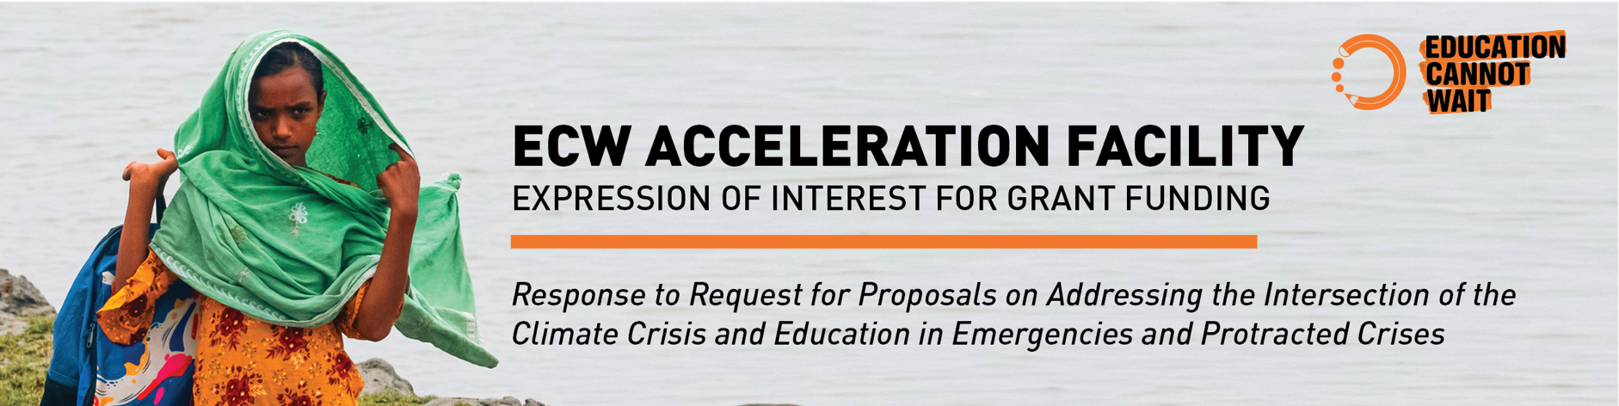

1. Project proposal

Requesting organization | [Add text here]
Address | [Add text here]
Project title (short and concise) | [Add text here]
Name, email and telephone contact for the organizational focal point for this project. | [Add text here]
Total amount requested (USD) | [Add text here]
Duration of ECW-funded activities (number of months).  Start date of the grant will be the date of countersignature of the grant confirmation letter. | [Add text here]
RFP Objective (select one)  If your organisation is responding to more than 1 objective in the RFP, please complete separate Expression of Interests for each objective | 1) Develop and disseminate Global Guidance for the greening of Temporary Learning Spaces  2) Undertake research and advocacy on Loss and Damage and Education in Emergencies and Protracted Crises.  3) Scale up and share effective models of locally led, innovative climate-smart EIEPC programming

SECTION 1: Overall Aim and Key Results
GUIDANCE (delete when completed)

After reading the Request for Proposals and keeping in mind the overall goal of the Acceleration Facility “to fund strategic initiatives which tackle systemic barriers to quality education and stimulate and catalyze advancements in the Education in Emergencies and Protracted Crises ecosystem” please:

- Briefly summarize the problem your proposal seeks to address
- Describe the overall aim of the project and the key results that will be delivered

Problem Statement
[Add text here]

Overall Aim
[Add text here]

Expected Results
[Add text here]

[1-2 pages total]

SECTION 2: Project Summary and Proposed Outcomes and Activities
GUIDANCE (delete when completed)

- Using the structure below, provide a clear, concise description of the project, including the proposed outcomes and associated activities (add or delete outcomes and activities as necessary).
- Please indicate in your summary description which priority countries the proposed initiatives link to.
- Use diagrams and charts as necessary to clarify the concepts and approach to be taken.
- If space is insufficient, please attach additional supporting documents as annexes.

Summary of Project and Proposed Interventions:
[Insert text here]

Outcome 1:
[Insert text here]

Activities:
  - [Insert text here]
  - [Insert text here]

Outcome 2:
[Insert text here]

Activities:
  - [Insert text here]
  - [Insert text here]

[1-2 pages total]

SECTION 3: Organisational expertise, implementation and coordination

GUIDANCE (delete when completed)

- Please use the structure below to describe the expertise of your organisation in relevant fields, and to describe how the project will be implemented. Include a description of the implementing partners (e.g. sub-grantees), management arrangements and key partnerships, and how this project links in to, and avoids duplication and overlap with, similar initiatives. Demonstrate that your organisation is able to engage the diverse organisations needed to meet the proposed project’s objectives, noting the importance of working with and through local/national organisations and relevant Ministries, and building local capacity, as appropriate.

Organisational expertise
(remembering ECW’s focus on Education in Emergencies and Protracted Crises specifically)
[Add text here]

In-country presence/partnerships with programme countries
[Add text here]

Implementation arrangements and implementing partners
[Add text here]

Linkages with similar initiatives
[Add text here]

[1-2 pages total]

SECTION 4: Monitoring, Evaluation & Learning

GUIDANCE (delete when completed)

- Describe how you plan to monitor and report your project’s progress toward the expected results and how you plan to evaluate the success of the proposed initiative including results
- Describe how you will disseminate any findings with the wider sector

[1 page total]

